A high efficiency video coding system based on joint fractal and H.264/AVC
Shiping Zhu※, Dongyu Zhao, Ling Zhang
Department of Measurement Control and Information Technology, School of Instrumentation Science and Optoelectronics Engineering, Beihang University, Beijing 100191, China.
Abstract: The H.264/AVC standard yields higher coding efficiency than other video coding standards. This is because it uses the rate-distortion optimization (RDO) technique, which selects the optimal coding mode and a reference frame for each macroblock (MB). In order to achieve this, the encoder has to encode a given block by exhaustively using all kinds of combinations (including different intra and inter-prediction modes). As a result, the computational complexity of video coding in H.264/AVC is extremely high. On the other hand, fractal video coding is a relatively new video compression method. Its attraction is due to the high compression ratio and the simple decompression algorithm. There are advantages and disadvantages in the both video coding methods. In this paper, a new inter prediction is proposed in an effort to reduce the P frame encoding time, by using the fractal prediction encoding. The experimental results show a 0.14 peak signal-to-noise ratio loss, a 50% bitrate decrease, and an 81% encoding time reduction on average comparing with the latest H.264/AVC reference codec JM18.5. Moreover, the proposed joint fractal and H.264/AVC codec outperforms the recent alternative codecs by improving the H.264/AVC, especially in much bitrate saving and encoding time reduction.
Keywords: fractal; H.264/AVC; video coding; inter mode decision.

1. Introduction
The H.264/AVC standard, is a well-known technique employed to improve video coding quality . Its coding efficiency can improve approximately 40-60% compared to the Motion Picture Experts Group (MPEG)-2 and H.263 standards . For better motion compensation, H.264/AVC supports variable block sizes, multiple reference frames, and quarter sample accuracy motion estimation. However, the computational complexity of a H.264/AVC system is too high to apply in real-time systems. Motion estimation consumes approximately 80% of the entire encoding time . To reduce the complexity, fast-motion estimation for multiple reference frames is a significant consideration.
The number of reference frames can be a maximum of 16 in the H.264/AVC coder. Obviously, the complexity greatly increases compared with the previous standards . Recently, many fast algorithms have been proposed to accelerate the speed of motion estimation for multiple references . Chen presented the composed vector from the result of the previous frames with simple additions . Then, the refine search is used to improve the accuracy . Kim used a temporary motion vector to predict the optimal vector between successive frames with a vector map. Next, a narrow search is used to refine its accuracy . Su took into account the correlation/ continuity of motion vectors among different reference frames to find the estimated vector . These algorithms employ the previous vectors to calculate the next vector. However, these kinds of methods are highly dependent on the previous results.
Fractal video coding is a new coding method which is based on self-similarity within the different portions of the image or different frames. It might be revolutionary in the world of data compression because of its high compression rate and little time taken for encoding compared with other methods; however, it suffers from some problems such as the decoding quality is not satisfied . Beaumont was the first to extend Jacquin’s still image coding technique straightforwardly to video sequence coding . He presented a 3-D FBC scheme using a 12-frames memory, with a range cube of 4×4×4 pixels and a domain cube of 12×12×12 pixels. Although the data compression was impressive, the picture quality was poor and severe blocking artifacts were present. The failure can be mainly attributed to inadequacy of fractal coding in modeling high-pass spatial and temporal edges. To further improve the encoding quality, a novel 3-D partition of input frames was introduced by Lazar . However, they suffered from the same drawbacks as 2-D fractal coding schemes, that is, the computational expense of finding the best matching between range cube and a domain pool.
There are advantages and disadvantages in the above two video coding methods, the H.264/AVC coder can produce high quality decoding video and the fractal video coding is time saving. In this paper, a new inter prediction is proposed in an effort to reduce the P frame coding time, by using the fractal prediction coding.
The paper is organized as follows. In Section 2, the background mathematical theory for fractal image compression is presented. The two basic fractal compression algorithms for motion images, the cube-based method and the frame-based method, are discussed, and their advantages and disadvantages are highlighted. Some combined methods are discussed, in particular a hybrid cube- and frame-based algorithm and a combined fractal compression and motion compensation algorithm. In Section 3, the proposed video system is described, and the detailed procedure is presented. In Section 4, the results of numerical tests are given. Finally, some conclusions are presented in Section 5.

2. The fractal compression theory and mathematical background

2.1 Complete metric space
A metric space is an ordered pair (M, d) where M is a set and d is a metric on M, i.e., a function, d: M×M→R, such that for any x, y, z∈M, the following holds:
a. d(x, y) ≥ 0 (non-negative);
b. d(x, y) = 0 if and only if x=y (identity of indiscernibles);
c. d(x, y) = d(y, x) (symmetry) and
d. d(x, z) ≤ d(x, y)+d(y, z) (triangle inequality).
The function d is also called distance function or simply distance. Often, d is omitted and one just writes M for a metric space if it is clear from the context what metric is used. A metric space M is called complete (or a Cauchy space) if every Cauchy sequence of points in M has a limit that is also in M or, alternatively, if every Cauchy sequence in M converges in M.

2.2 Contractive maps
Let X be a metric space with metric d. A map ω: X→X is Lipschitz with Lipschitz factor s if there exists a positive real value s such that
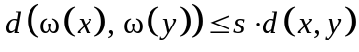 (1)
for every x, yX. If the Lipschitz constant satisfies s<1, then ω is said to be contractive with contractivity s.

2.3 Contractive mapping fixed-point theorem
Let X be a complete metric space and f: X→X be a contractive mapping. Then there exists a unique point 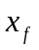X such that for any point xX.
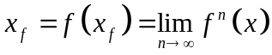 (2)
Such a point is called a fixed point or the attractor of the mapping f. We say a map is contractive when it brings points closer to each other. For example, let us consider the map f(x) = x/2 — this map is contractive because if we take any initial value to be x, then by calculating , 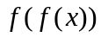, 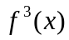, ... , the convergence will be towards the fixed point 0.

2.4 Generalized collage theorem
Let f be eventually contractive with exponent n, and then there exists a unique fixed point X, such that for any xX,
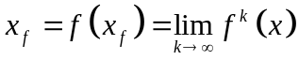 (3)
In that case,
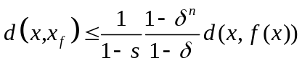 (4)
Where s is the contractivity factor of 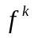 and is the Lipschitz factor of .
Let X be a complete metric space. An iterated function system is a collection of contractive maps 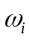: X→X for i=1,…, n.
By the contractive mapping fixed-point theorem, iterated function system is just a collection of maps that defines a unique attractor. As the attractor is unique, it is completely specified by the map ω and initial value independent .
The fractal image and video encoding is an inverse problem that we need to find an IFS which has the whole image as its attractor. However, no completely general solution to this problem exists to the date as only local self-similarities exist in natural images. Therefore, the IFS is extended to form the Partitioned Iterated Function System (PIFS) which is a collection of contractive maps :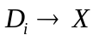, for i=1,…, n where X is a complete metric space and 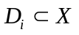, for i=1,…, n. PIFS makes it possible to encode more general and non-self-similar sets and by using collage coding method, a similar part of the region can always be found for every small part of a region.

2.5 Affine transformation
The general form of the affine transformation in R2 is
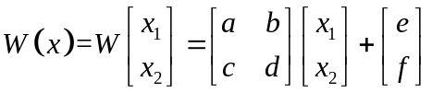 (5)
The matrix 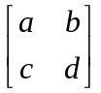 is equal to 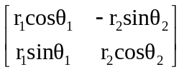.
So, Eq. (5) can be written as:
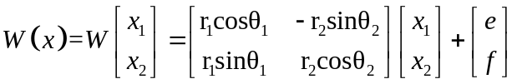 (6)
Affine transformations are able to skew, stretch, scale, rotate and translate an input image. There are thousands or millions of transformations, therefore, to make the compression process easier (reducing the domain pool, decreasing the searching time); Arnaud Jacquin suggested having only eight transformations for blocks which will be described later in details.

2.6 Fractal image coding
The fundamental idea is coming from the Partitioned Iterated Function System (PIFS). Suppose the original gray level image f is of size m×m. Let the range pool R be defined as the set of all non-overlapping blocks of size n×n of the image f, which makes up (m/n)² blocks. In order to obey the Contractive Mapping Fixed-Point Theorem, the domain block must be 2 times longer than the range block. Thus, let the domain pool D be defined as the set of all possible blocks of size 2n×2n of the image f, which makes up (m−2n+1)² blocks. For each range block v from the R, the fractal affine transformation is constructed by searching all of the domain blocks in the D to find the most similar one and the parameters representing the fractal affine transformation will form the fractal compression code of v. To execute the similarity measure between range block and domain block, the size of the domain block must be first sub-sampled to 8×8 such that its size is the same as v. Let u denote a sub-sampled domain block. The similarity of two image blocks u and v of size n×n is measured by mean square error (MSE) defined as
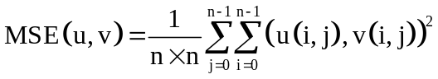 (7)
And peak signal to noise ratio (PSNR), an important decode image quality measure parameters, is defined as
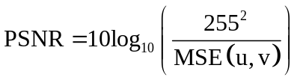 (8)
The fractal affine transformation allows the eight transformations of the domain block u in the Dihedral transformations. The eight transformations T_{k}: k = 0, 1,...,7 can be expressed by the matrices in Table 1, in which the origin of u is assumed be located at the center of the block. By the eight transformations, eight transformed blocks are generated and denoted by u_{k}: k = 0, 1 ,..., 7, respectively, where u₀ is equal to the original sub-sampled domain block u.
Table 1. The 8 transformations in the Dihedral group
T₀ | T₁ | T₂ | T₃ | T₄ | T₅ | T₆ | T₇
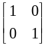 | 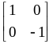 | 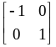 | 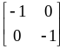 | 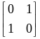 | 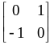 | 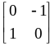 | 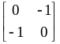
The fractal affine transformation also allows the contrast scaling p and the brightness offset q on the transformed blocks. Thus the fractal affine transformation φ of u(x, y) can be expressed as
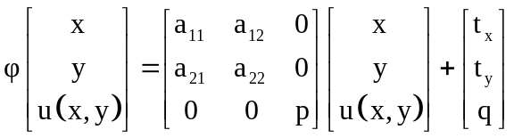 (9)
Where the sub-matrix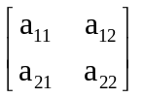represents the one of eight Dihedral transformations in Table 1 and (t_{x}, t_{y}) is the coordinates of the domain block. Thus the similarity is to minimize the quantity 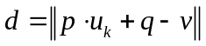. Here, p and q can be computed directly by
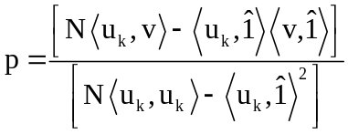 (10)
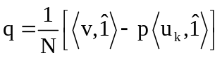 (11)
Where N is the number of pixels of the range block, 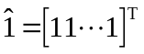, and <> represents inner product.
Finally, as u runs over all the blocks in the domain pool, a set of parameters t_{x}, t_{y}, p, q, and k are obtained and constitute the fractal compression code of v. Finally, as v runs over all blocks in the range pool, the encoding process is completed.
The decoding in fractal compression is much faster compared with the encoding; here the time depends on the number of iterations, however, we will see that only a few iterations (usually after four to eight iterations) are required to reach the fixed point or the attractor. The following are the steps used in the decompression process of fractal based compression:
- Makes up all affine transformations from the compression codes;
- Chooses any initial image and performs the affine transformations on the image to obtain a new image. The transformation is proceeded recursively according to the Contractive Mapping Fixed-Point Theorem and Collage Theorem until the sequence of images converges to the encoded image .
- The stopping criterion of the recursion is designed according to the user’s application and the final image is the retrieved image of fractal coding.

2.7 Fractal video coding
For fractal video compression, there are two extensions of still image compression. They are frame-based compression and cube-based compressions. In frame-based compression as shown in Fig. 1, video clips and motion pictures are naturally divided into segments according to scene changes. Each segment, beginning with an initial frame, is called an intra-coded frame, or I-frame. Each frame can then be coded mainly using the motion codes by referencing its preceding frame called a P-frame, as a predicted frame from its pre-process.
In a two-dimensional fractal video compression system, the I-frames are compressed using image compression technique. The I-frames are coded by 2-to-1 local and global self-referencing fractal codes. While decoding such an I-frame, a hidden frame has been created in each iteration.
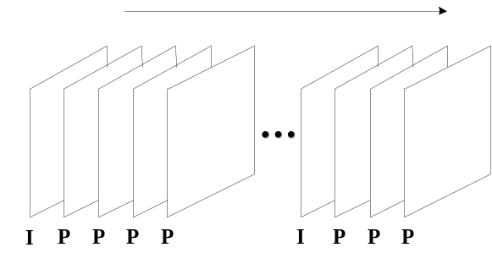
Fig. 1. Video clip frames
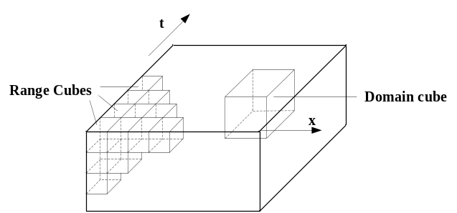
Fig. 2. Range cubes and domain cube in a GOF
In a cube-based compression as shown in Fig. 2, image sequences are portioned into groups of frames, and every group of frames is portioned into non-overlapped cubes of ranges and domains. The compression codes are computed and stored for every cube. Every group of frames is called GOF. Each GOF can be compressed and decompressed separately as an entity. Assuming temporal axis along the sequence, every GOF can be considered as a large cuboid. In fractal compression, each GOF is portioned into non-overlap small cuboids. Each cuboid is called a range cuboid and denoted as R. The sizes of edges of R may be different; especially the edge in the temporal direction may vary from the horizontal to the vertical direction. In order to obtain the approximate transformation of R, another overlap partition is necessary whose small parts are called domain cuboids. The horizontal and the vertical edges of the domain cuboids are twice as large as the range cuboids respectively. But the temporal edge of the domain cuboid is the same as the one of the range cuboids.
The frame-based compression can obtain high compression ratio, but the compression of the current frame is related to the previous decompressed image, so there is a delay between frames when decompressed and error may spread between frames. The cube-based method can obtain the decompressed images with high qualities. Some studies use adaptive partitioning to improve the compression ratio. However, if transmission error is considered, the adaptive partition is not suitable because the partition information may be lost during transmission .

3. The proposed video coding system based on joint fractal and H.264/AVC
The computational complexity of video coding in H.264/AVC is extremely high, especially the P frame prediction; On the other hand, fractal video compression coding has high compression ratio and the simple decompression algorithm. There are advantages and disadvantages in the above video coding methods. In this paper, a new inter prediction is proposed in an effort to reduce the P frame coding time of H.264/AVC, by using the fractal prediction coding. The proposed system encoding block diagram is shown in Fig. 3, and the decoding block diagram is shown in Fig. 4. In H.264/AVC, the blocks in P frame can be intra-/inter- prediction. But the P frame in our system is the only inter-prediction. In the encoding system diagram, the fractal encoder and PIFS take the place of MC in H.264/AVC. The fractal coefficients through the fractal encoder will be entropy coded with residuals.
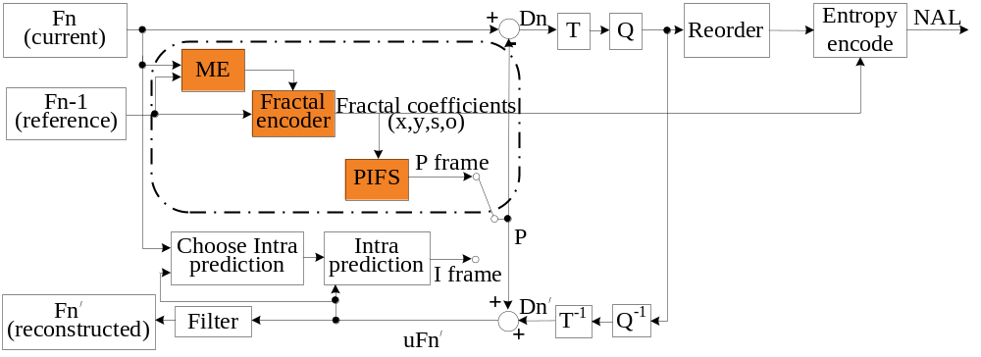
Fig. 3. Block diagram of the proposed encoder system
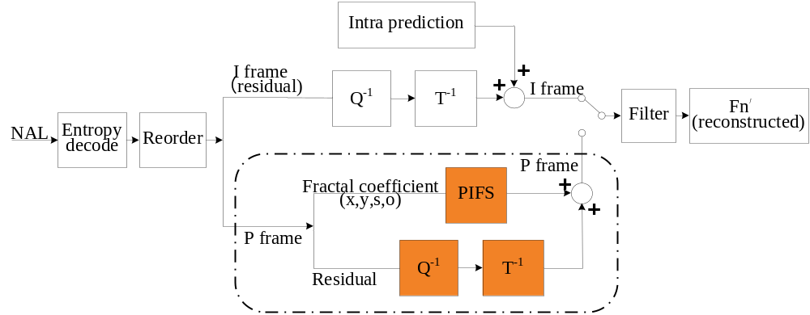
Fig. 4. Block diagram of the proposed decoder system
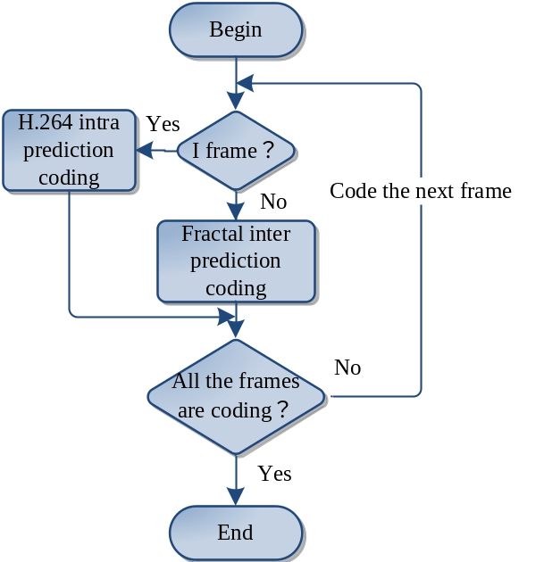
Fig. 5. The overall procedure of the proposed encoder
Based on Fig. 5, the proposed encode system can be described as follows:
1. If the current frame is I frame (the first frame must be I frame), encode I frame just like in H.264/AVC. Then we get a reference frame for later P frames.
2. If the current frame is P frame, use the pre-frame as a reference frame to encode the current frame. So the range blocks are in the current frame and the domain pools (search area) are in the reference frame. Searching the best matching macroblock in the search area of the current macroblock is called as motion estimation as shown in Fig. 6.
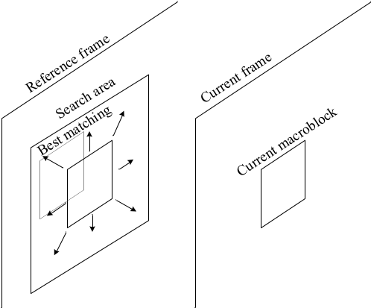
Fig. 6. Fractal affine transformation
The concrete encoding processes are shown as follows.

3.1 I Frame encoding
H.264/AVC offers four intra modes for 16×16 luma blocks and nine prediction modes for 4×4 luma blocks . The H.264/AVC encoder may test all possible modes, which is called the full mode decision, by evaluating the cost associated with each of the intra modes and then select the best mode with the smallest cost. The cost is usually defined to be Lagrangian RD cost. Select the best prediction mode among all possible intra predictive modes by minimizing the Lagrangian function.
A prediction macroblock is generated and subtracted from the current macroblock to form a residual macroblock; this is transformed, quantized and encoded. In parallel, the quantized data are re-scaled, inverse transformed and added to the prediction macroblock to reconstruct a coded version of the frame which is stored for later prediction. In the decoder, a macroblock is decoded, re-scaled and inverse transformed to form a decoded residual macroblock. The decoder generates the same prediction that is created at the encoder and adds this to the residual to produce a decoded macroblock.

3.2 P Frame encoding
Define the reference of the current frame, which is the I frame or the P pre-frame, then compute sum and square sum of all the possibility 16×16, 16×8, 8×16, 8×8, 8×4, 4×8, 4×4 blocks in current frame and reference frame.
The concrete P frame encoding process is shown as follows, and the flowchart is shown in Fig. 7.
1) Divide the current frame into non-overlapping range blocks of size 16×16 to form the range pool R;
2) Code each range block.
For each range block v from the R, the fractal affine transformation is constructed by searching the domain blocks in a search area in the D. The search area is ±7 pixels (can be bigger or smaller which can be defined, but ±7 pixels are the fit number we tested) bigger than range block, shown as in Fig. 6. If the min-RMS (Root Mean Square) between the v and domain block is smaller than T_16 (a constant number can be defined, here is 10.5), the domain block can be thought as fit well, we can continue to the next range block. The minimum RMS means the best matching. It is determined by
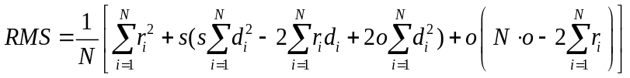 (12)
where the contrast factor s is
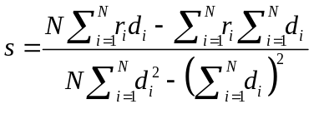 (13)
the offset factor o is
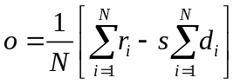 (14)
and is pixel value of Range block (R), 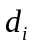 is pixel value of Domain block (D), N is the number of pixels in the block.
If both the RMS are bigger than T_16, then the range block v will be divided into two 16×8 sub-range blocks separately, find two minimum RMS, if both minimum RMS are smaller than T_16, then we can continue to the next range block;
Other else, we can divide the range block into two 8×16 sub-range blocks separately, find two minimum RMS, comparing with T_16:
If both minimum RMS are smaller than T_16, then we can continue to the next range block;
If both minimum RMS are bigger than T_16, then the range block v will be divided into four 8×8 sub-range blocks separately, find four minimum RMS, if all minimum RMS are smaller than T_8 (here is 8.0), then we can continue to the next range block;
Other else, an 8×8 sub-range block (the four 8×8 sub-range blocks should be proceed by the same way) can be divided into two 8×4 sub-sub-range blocks separately, find two minimum RMS, if both minimum RMS are smaller than T_8, then we can continue to the next range block;
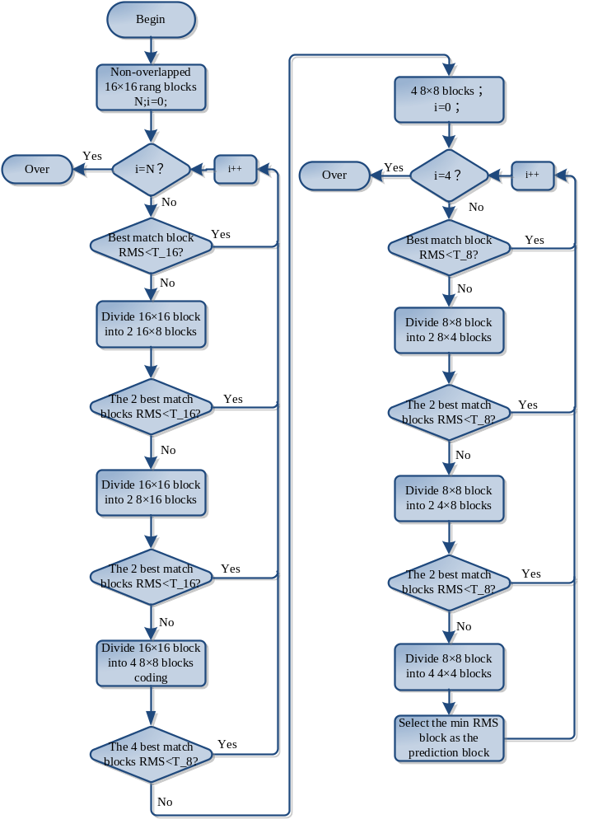
Fig. 7. Flowchart of P frame encoding process of the proposed coding system
Other else, we can divide the range block into two 4×8 sub-sub-range blocks separately, find two minimum RMS, comparing with T_8, if both minimum RMS are smaller than T_8, then we can continue to the next range block;
Other else, we have to divide the 8×8 sub-range block into four 4×4 sub-sub-range blocks, in this case, we need to find the minimum RMS matching block, and then we can continue to the next block.
3) Save the following fractal coefficients:
• The location (x, y) of the domain block;
• Contrast (scaling factor);
• Offset.
4) Continue doing the same for the rest of the range blocks until the last one is reached.
After all macroblocks are predicted, a prediction frame is generated and subtracted from the current frame to form a residual frame; this is transformed, quantized and encoded. In parallel, the quantized data are re-scaled and inverse transformed and added to the prediction frame to reconstruct a coded version of the frame which is stored for later predictions. In the decoder, a macroblock is decoded, re-scaled and inverse transformed to form a decoded residual macroblock. The decoder generates the same prediction that is created at the encoder and adds this to the residual to produce a decoded macroblock. After all macroblocks are decoded, a decoded frame is formed.

3.3 Deblocking filter
The application of a 4×4 transform tends to promote blocking artifacts in the reconstructed video, especially at lower bitrate. Therefore, a normative in-loop deblocking filter is employed in H.264/AVC. The reconstructed frames are filtered before the application of motion compensation in the prediction loop. The functionality of this filter is essential for the subjective performance of the coder, especially at lower bitrate .
The strength of the filter is determined by the chosen macroblock mode, the existence of nonzero transform coefficients, the applied quantizer, and by the motion vector activity. In general, stronger filtering is applied to intra blocks than inter blocks. A maximum of two pixels on each side of the boundary of two adjacent blocks are affected by applying the deblocking filter on 4×4 blocks. Intra blocks coded with the intra 16×16 mode are filtered only at the macroblock boundaries .
The mode of operation of the deblocking filter needs to be adjusted for the application of the P frame, on account of P frames in the proposed video coding system are composed of inter prediction. Most of the sizes in the inter prediction are 16×16 and the deblocking of macroblock is filtered only performed at the macroblock boundaries. Hence, the number of filter operation is reduced.
For example, if the 16×16 transform is employed, a macroblock has eight block boundaries to be filtered. These are four on the left and four at the top. The boundaries to the right and at the bottom are encountered for the next blocks. Accordingly, if the 16×8 and 8×16 transforms are employed, a macroblock has twelve block boundaries to be filtered; if the 8×8 transform is employed, a macroblock has sixteen block boundaries to be filtered similarly. For a 8×8 sub-block, if it is divided into two 4×8 or 8×4 blocks, the number of filtered boundaries is six; if it is divided into four 4×4 blocks, the number of filtered boundaries is eight.

3.4 Entropy coding
The entropy encoder converts a series of symbols representing elements of the video sequence into a compressed bit stream suitable for transmission or storage. Input symbols may include quantized transform coefficients (run-level), motion vectors (x and y displacement vectors for each motion compensated block, with integer or sub-pixel resolution), markers (codes that indicate a resynchronization point in the sequence), headers (macroblock headers, picture headers, sequence headers, etc.) and supplementary information (‘side’ information that is not essential for correct decoding) .
H.264/AVC features two entropy coding methods, variable length coding and arithmetic coding. Variable length coding contains Exponential Golomb Coding and CALVC.
Run-length coding is employed for the transform coefficients. The well-known zig-zag scan is employed to represent the transform coefficients as (level, run) symbols. In the case of field-based encoding of interlaced material, an alternate scan is used that accounts for the modified signal statistics in the fields of interlaced video .
Here, in the P frame coding, we use the frame-based coding, so a zig-zag scan is employed to represent the (level, run) symbols. We use the CAVLC coding for transform coefficients; the other fractal parameters such as scale, offset, x and y use the symbol Exponential Golomb Coding to form the bit stream.

4. Experimental results and discussion
The proposed high efficiency hybrid video coding system joint fractal and H.264/AVC is implemented and compared with H.264/AVC Reference Software JM18.5 . The simulations are run on an Intel 2.5 GHz two quad CPUs processor with 3.46 GB DDR RAM.
The sequences used for the simulations can be divided into three types: low speed sequences (bridge close, forman and mobile); normal speed sequences (coastguard, flower and Paris) and high speed sequences (bus, football and Stefen). All of them are in CIF size and 50 frames are coded. Frame filtering is applied. The configuration settings of the JM18.5 simulation environment are shown in Table 2. Specially, in the configurations of the proposed video coding system, the parameters of Tol_16, Tol_8 and Tol_4 are set as 10.5, 8.0 and 6.0 respectively.
We defined three measures for evaluating the encoding performance, including ∆PSNR, ∆BR, ∆T which are defined as follows:
(15)
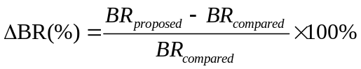 (16)
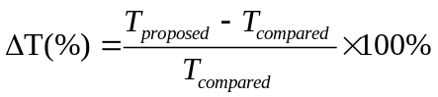 (17)
Where compared value can be acquired from or JM18.5. It should be noted that positive values for the ∆PSNR, ∆BR and ∆T indicate increments and negative values indicate decrements. So a positive value in ∆PSNR and a negative value in ∆BR and ∆T are results of good performances.

Table 2. Configuration settings of the simulation environment
Profile IDC | Main
LevelIDC | 30
Frame rate | 50 Hz
Number of reference frame | 1
Intra period | 0 (IPPP)
QP | 24, 28, 32
Hadamard transform | Enabled
RDO | Enabled
Motion search range | ±7 pixels with ¼-pel accuracy
Motion estimation | Full search
Symbol mode | CAVLC

4.1 Subjective performance
Two sequences called “foreman” and “bus” are used for the subjective performance evaluation of the proposed video coding system. They belong to low and high speed sequences respectively. Fig. 8 shows the decode details of the 2nd, 26th and 50th frames of “foreman” sequence coded with QP=28. Fig. 9 shows the decode details of the 2nd, 26th and 50th frames of the “bus” sequence coded with QP=28.
As can be seen, the proposed video coding system reveals a pleasing subjective quality no matter when the sequences are low or high speeds. And the subjective quality retains well when the frame number increases.
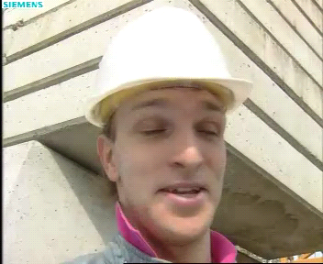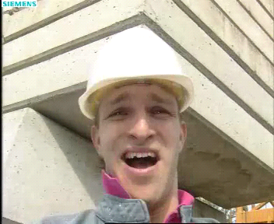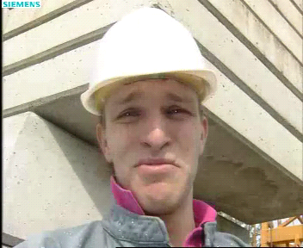
(a) The 2nd frame (b) The 26th frame (c) The 50th frame
Fig. 8. Decoded details of “foreman” coded with QP=28.
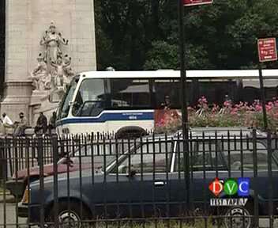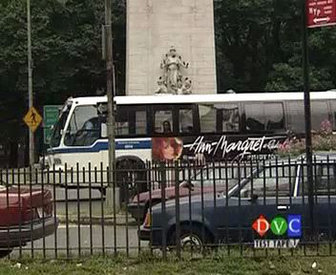
(a) The 2nd frame (b) The 26th frame (c) The 50th frame
Fig. 9. Decoded details of “bus” coded with QP=28.

4.2 Performance comparisons with and JM18.5
Table 3 shows the PSNR gains, encoding time and bitrate saving with the simulation conditions given above compared with and JM18.5. In , the proposed fractal video coding system is latest reported, and it can represent the latest high level of video coding system based on fractal. The proposed video system is excellent on PSNR and bitrate saving comparing to . Overall, average encoding time increment is 14%, bitrate saving is 54% and PSNR gain is 6.78 dB which can be observed in Table 3. Although the average encoding time of the proposed video coding system is 14% longer, but the cardinal number of time here is small, so the encoding time we spent is also little. Compared with JM18.5, the average encoding time saving is 81%, bitrate saving is 50% and PSNR gain is -0.14 dB. Apparently, there is a great improvement on encoding time and bitrate saving compared to JM18.5. The PSNR which is reduced by 0.14 dB can be ignored for there is no influence in subjective performance.
Table 3. Performance comparisons of the proposed video coding system with and JM18.5
Sequences |  | Compared with |  |  | Compared with JM18.5
 |  | ΔPSNR (dB) | ΔBR (%) | ΔT (%) | ΔPSNR (dB) | ΔBR (%) | ΔT (%)
Low speed | foreman | 5.02 | -29 | 44 | -0.28 | -5 | -82
Low speed | bridge close | 4.23 | -42 | 38 | 0.33 | -45 | -78
Low speed | mobile | 9.55 | -69 | -33 | -0.22 | -57 | -81
Normal speed | coastguard | 5.48 | -63 | 5 | 0.01 | -71 | -84
Normal speed | flower | 10.35 | -65 | 23 | -0.07 | -62 | -81
Normal speed | Paris | 6.07 | -51 | 18 | 0.12 | -41 | -78
High speed | bus | 7.39 | -76 | 40 | -0.38 | -66 | -74
High speed | football | 5.71 | -26 | 2 | -0.38 | -53 | -87
High speed | Stefen | 8.07 | -65 | -15 | -0.4 | -50 | -81
ΔMean |  | 6.87 | -54 | 14 | -0.14 | -50 | -81

4.3 Performance comparisons with other fast algorithms
Table 4 shows the performance comparisons with other P frame improved algorithms . Most of other methods can reduce the encoding time but with the increase of bit stream and the decrease of PSNR. So the proposed system shows its excellence in optimizing two parameters of encoding time and bit stream, with negligible decrease in PSNR.
Table 4. Performance comparisons with other fast algorithms
Algorithms | ΔPSNR (dB) | ΔBR (%) | ΔT (%)
S. H. Ri’s | -0.04 | 2.4 | -45
K. I Lee’s | -0.03 | 0.87 | -58.39
J. C. Chiang’s | -0.06 | 5.67 | -97
B. Lee’s | -0.11 | 2.54 | -64.8
S. Milani’s | -0.04 | 5.14 | -62
Proposed | -0.14 | -50 | -81
Table 5 shows the experimental results comparisons between the proposed method and in detail.
Table 5. Performance comparisons with K. I Lee’s
Sequences | QP | Method | PSNR (dB) | BR (kbit/s) | Time (s)
mobile | 24 | JM18.5 | 37.10 | 7141.128 | 1120.018
mobile | 24 | K. I Lee’s | 37.58 | 4805.740 | 251.685
mobile | 24 | Proposed | 38.60 | 2003.064 | 77.175
mobile | 28 | JM18.5 | 33.88 | 4793.640 | 1051.585
mobile | 28 | K. I Lee’s | 34.31 | 2728.500 | 240.847
mobile | 28 | Proposed | 35.16 | 1414.992 | 78.627
mobile | 32 | JM18.5 | 30.58 | 2975.096 | 975.017
mobile | 32 | K. I Lee’s | 30.96 | 1314.130 | 230.643
mobile | 32 | Proposed | 31.5 | 1150.336 | 80.184
coastguard | 24 | JM18.5 | 37.03 | 4484.600 | 1295.770
coastguard | 24 | K. I Lee’s | 37.43 | 3819.830 | 234.218
coastguard | 24 | Proposed | 38.39 | 880.872 | 71.390
coastguard | 28 | JM18.5 | 34.16 | 2728.432 | 1213.147
coastguard | 28 | K. I Lee’s | 34.36 | 2235.890 | 222.860
coastguard | 28 | Proposed | 35.27 | 759.272 | 71.346
coastguard | 32 | JM18.5 | 31.44 | 1484.456 | 1093.987
coastguard | 32 | K. I Lee’s | 31.30 | 1090.350 | 213.157
coastguard | 32 | Proposed | 32.03 | 692.096 | 71.738
Stefen | 24 | JM18.5 | 38.17 | 4885.440 | 1056.499
Stefen | 24 | K. I Lee’s | 38.71 | 3383.784 | 235.519
Stefen | 24 | Proposed | 39.47 | 1530.504 | 74.204
Stefen | 28 | JM18.5 | 35.10 | 3190.280 | 980.912
Stefen | 28 | K.I Lee’s | 35.63 | 1868.640 | 227.262
Stefen | 28 | Proposed | 36.18 | 1106.168 | 74.625
Stefen | 32 | JM18.5 | 31.92 | 1945.472 | 896.022
Stefen | 32 | K. I Lee’s | 32.48 | 952.168 | 221.469
Stefen | 32 | Proposed | 32.67 | 959.888 | 75.998
In Fig. 10, B. Lee’s algorithm is used for an objective comparison of the encoding performance . RD plots for the IPPP frame structure are given for the sequences “Mobile”, “Coastguard” and “Stefan”. The RD cure of the proposed method is in the upper left side comparing to that of B. Lee’s method. A careful analysis of the results reveals that our algorithm performs better in terms of running time and bitrate saving for lower quantization parameters (QP) in the non rate controlled ones. This is due to the P frame encoding is not associated with QP in the proposed system, so when the QP is increased, the bit stream formed by P frame is not decreased. When the QP is decreased, the bit stream formed by H.264/AVC is increased rapidly, but slower in the proposed system.
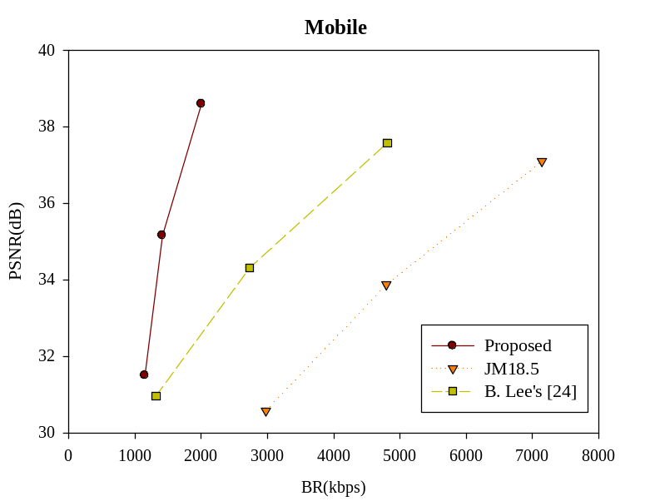
(a) Mobile
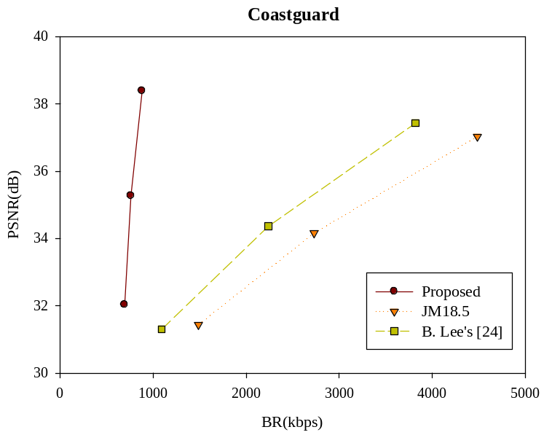
(b) Coastguard
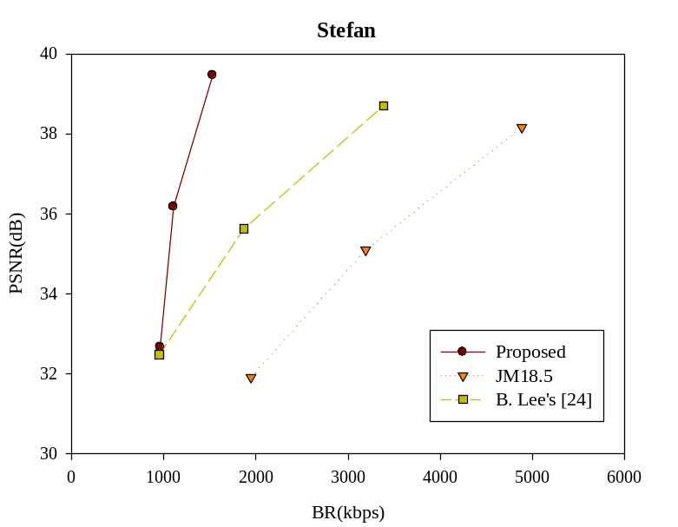
(c) Stefan
Fig. 10. RD plots comparisons between JM18.5, B. Lee’s and the proposed system.

5. Conclusion
In this paper, we proposed a new video coding system based on joint fractal and H.264/AVC. The experimental results show that the proposed system reduces encoding time expense about 81% and bitrate about 50% while maintaining coding performance with negligible 0.14 dB decrease in PSNR, comparing with the latest JM18.5; and the proposed system increases 6.87 dB in PSNR and reduces bitrate about 54% while a little increase in encoding time expense, comparing with a new fractal video coding method in . Meanwhile, the proposed video coding system performs much well comparing to some recent reported alternative video coding systems which are based on improving the H.264/AVC, especially in much bitrate saving and encoding time reduction.
Then we can conclude that we use the fast coding advantage of fractal video coding and the high quality advantage of H.264/AVC to propose a successful novel high efficiency video coding system based on joint fractal and H.264/AVC.

Acknowledgement
This project is funded by the National Natural Science Foundation of China (NSFC) under grants No. 61375025, No. 61075011, and No. 60675018, also the Scientific Research Foundation for the Returned Overseas Chinese Scholars from the State Education Ministry of China. The authors would also like to express their appreciations to the reviewers for their through review and very helpful comments, which help improving this paper.
References

 This project is funded by the National Natural Science Foundation of China (NSFC) under grants No. 61375025, No. 61075011, and No. 60675018, also the Scientific Research Foundation for the Returned Overseas Chinese Scholars from the State Education Ministry of China. ※Corresponding author: Shiping Zhu E-mail addresses: spzhu@163.com (Shiping Zhu), dongyuzhao@msn.cn (Dongyu Zhao), zhangling_buaa@sina.com (Ling Zhang).

